ABSTRACT
This paper details the proposed project background, defines the project proposal and requirements and outlines a tentative schedule for the Single Interface for Multiple Services Architecture project.

BACKGROUND
The Single Interface for Multiple Services Architecture, referred to as S.I.M.S.A. for the remainder of the document, is a concept developed as a perpetual teaching tool for the Computer Science department at Saginaw Valley State University. The project was originally a side project that SVSU students, Kyle Reed and Mark White, were developing as a side project to learn more about socket based communication with the Java NIO libraries. Seeing the potential that the project had as a teaching tool, the project’s goals were steered toward creating a standardized API that would allow computer science students, of varying levels of expertise, to contribute to the project. The idea being that if students can build off of the projects that they’ve previously completed, they will have a better understanding of what is actually going on with the entire system and will be exposed to all of the aspects of a large scale project. Since the project would also require that students use a strictly defined API to create their projects, it would provide valuable simulation of working with other APIs and/or on collaborative projects. The idea behind interactive and compounded learning is the basis for Carnegie Mellon University’s well known ALICE project which aims to help students learn about algorithm development by giving them a 3D world to programmatically manipulate.

The S.I.M.S.A. project was loosely defined and an informal API was established. Early prototypes of the S.I.M.S.A. servers gained interest from other students in the department and work was underway to push the project toward its goal of being a teaching tool. The name Single Interface for Multiple Services Architecture was given to the project because it aimed to provide a single, language-independent interface to multiple service programs running on the system. After further development of the S.I.M.S.A. model, it was decided that services running on remote machines should also be able to be loaded by the server creating a large, disparate distributed system.

Currently, the S.I.M.S.A. prototype can dynamically load modules written in Java. It provides two TCP/IP sockets for communication between clients and modules using the Java NIO package’s SelectorChannels which allow the server to run on a minimal amount of threads while only opening three TCP ports on the system. Since Selectors can accept multiple connections on the same port, and because it processes messages from those connections iteratively, concurrency problems normally experienced by similar message routing systems are eliminated. Also, since it requires minimal ports to be opened to the Internet it poses less of a security risk than a normal server.

TECHNICAL DETAILS
The S.I.M.S.A. model is best thought of as a post office. It provides the communication channel between clients and services using a well defined and standardized interface. The post office takes messages that are wrapped in envelopes and addressed and sends them to the appropriate recipients. Similarly, the S.I.M.S.A. server takes messages from the clients and wraps them in S.I.M.S.A. XML wrappers and delivers them to the appropriate service. An XML un-wrapper removes the S.I.M.S.A. XML and presents the message to the service along with which client it came from and other relevant information. The following diagram roughly shows this transaction.

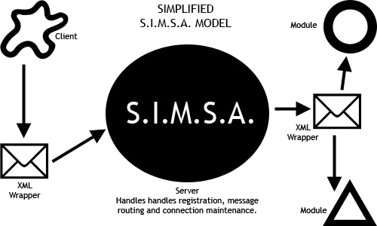

Since all communication over sockets is performed by MIME-encoded byte streams, it ensures that any language that can read and write to a Berkley socket will be able to communicate with the S.I.M.S.A. server and modules. Modules can be written in any language. Modules written in Java and are located on the local machine where the Server is running, can be dynamically loaded by the S.I.M.S.A. server. All modules are required to adhere to a certain, small set of server requests like the request to terminate if the module is causing problems within the server.

For simplicity, a S.I.M.S.A. library (the API) will also be developed to assist in the creation of clients and modules. It will provide the methods to wrap message bound for the server in the appropriate S.I.M.S.A. XML tags. The wrapper will also encode the message so that it will not conflict with the S.I.M.S.A. XML during routing. A similar library will be provided to unwrap and decode the messages outbound from the server. This will take any AML parsing demands off of the clients and modules making them easier to write.

PROPOSAL
I propose to finish the core of S.I.M.S.A. and develop the libraries that the system will use. The core will be completed using the Java NIO Selector and SocketChannel for connectivity and will implement standardized data types for internal registration and routing. External IPC will be handled via the communication server using S.I.M.S.A. defined XML tags. Internal IPC with threads will be managed with a “WatchDog” class that will allow the system to cleanly shutdown without any threads dangling behind.

I will also be engineering the rest of the project to create an easy to use and simple to implement API for use in developing clients and services. The API will be well documented and strictly enforced to ensure the robustness of the entire S.I.M.S.A. system. I will explicitly outline the S.I.M.S.A. model and define the requirements that compose a S.I.M.S.A. system. This will be needed is the project should ever be ported into another programming language or if the project should be embraced by the Open Source Community.

